|  |
| --- |
| Clinical Care Pathway |
| Palliative care transfers of Infants into Wales |
|  |

**Introduction:**

This pathway is suitable for any infant with a condition that means the clinician would not be surprised if they were to die within six months, and for whom parallel planning is therefore appropriate. ‘Parallel planning’ means putting into place arrangements for comfort care alongside interventions intended to prolong life in recognition of the possibility that those measures might fail.

**Overview of referral pathway:**

Below is a generalised flow chart of the teams and infrastructure involved in the transfer back of infants with urgent palliative care needs. The teams are numbered and the specific roles and tasks for each team are outlined in the text after it.

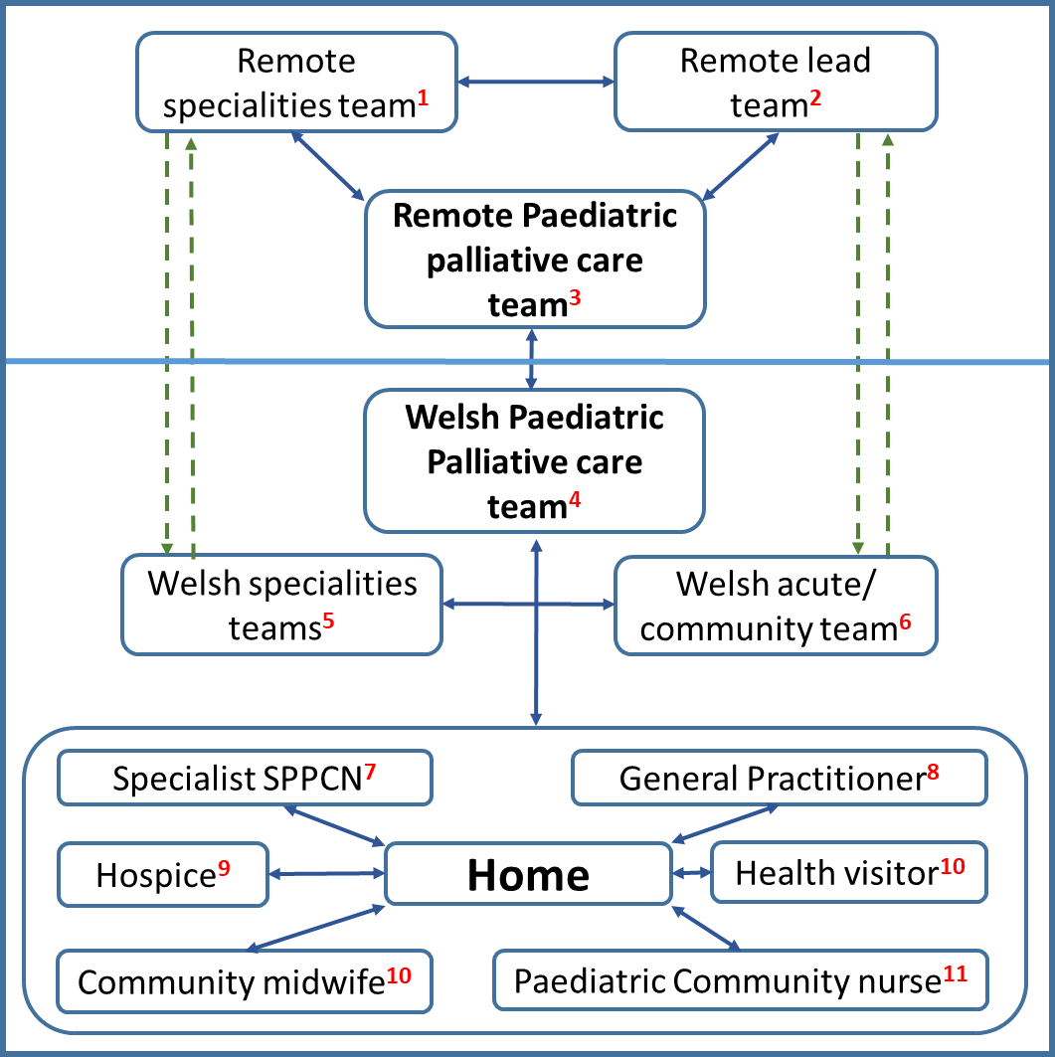

Specific steps, roles and responsibilities

Transfer of care for an infant for end of life care or parallel planning is complex and involves many separate teams handing over information. Co-ordination of that handover is the role of the two palliative care teams.

1. **Role of remote speciality team:**

□ Liaise with local speciality teams to refer and handover

□ Include baby’s GP/HV/Midwife in letters

□ To plan for procedures after death in conjunction with the PPC team, such as review need for referral to coroner

1. **Role of remote lead team (e.g. cardiology, neonatology, general paediatrics):**

□ Contact remote PPC team if not already involved

□ Liaise with local lead paediatric to refer and handover

□ Include baby’s GP/HV/Midwife in letters

□ To develop a transfer plan in conjunction with the remote PPC team and Welsh PPC team

□ Work with the remote PPC team as necessary to ensure a 14-day supply of regular and anticipatory symptom management medication is available, such as a paediatric ‘just in case box’

□ To arrange for home equipment as necessary, e.g. nasogastric tubes, suction

□ To arrange transport home as necessary

1. **Role of English Paediatric Palliative Care**

□ Establish direct link with Welsh PPC team

□ Include baby’s GP/HV/Midwife in letters

□ To develop a transfer plan in conjunction with the Welsh PPC team and lead team

□ To advise local lead team with symptom control plans and prescribing

□ Refer to hospice if appropriate. In Wales, there are separate referral processes for the palliative care team and the children’s hospices. Referral to palliative care does not automatically mean referral to hospice

□ To ensure a 14-day supply of regular and anticipatory symptom management medication is available, such as a paediatric just in case box (this is in conjunction with the English lead)

1. **Role of Welsh Paediatric Palliative Care medical team:**

□ Advise remote lead team to contact remote PPC team if not already involved

□ Establish direct link with remote PPC team

□ Advise remote teams regarding contacts for local lead paediatric and speciality teams

□ In conjunction with PPC CNS and family, create care plans, consider parallel planning and complete a Paediatric Advanced Care Plan (PAC-Plan) if appropriate

□ Include baby’s GP/HV/Midwife in letters

□ Be prepared to contact GP/local paediatrician/community paediatrician/local specialists if others have not

□ Add infant to the palliative care database and MDT patient list

□ Identify lead SPPCN/CCN

□ To identify a primary contact for the family

□ To notify community services as soon as possible

□ To develop a transfer plan in conjunction with the remote PPC team and lead team

□ If appropriate to arrange a home visit, ideally with the SPPCN, on the day of transfer

□ Be able to signpost staff to their own lines of support and supervision

□ To plan for procedures after death in conjunction with the SPPCN

1. **Role of Welsh speciality team:**

□ Include baby’s GP/HV/Midwife in letters

□ Open lines of communication between the tertiary specialists and the local paediatricians with a special interest in the speciality to plan for potential local admissions and support

□ To advise on specific medical issues that the infant may face

□ To be involved in parallel planning in conjunction with the PPC team

1. **Role of Welsh acute and/or community paediatric team**:

□ Include baby’s GP/HV/Midwife in letters

□ To arrange for open access in the local paediatric assessment unit

□ To be involved in parallel planning in conjunction with the PPC team and arrange any medium- or long-term follow-up appointments that become necessary

1. **Role of Specialist Paediatric Palliative Care Nurse (SPPCN)**

□ To provide written information to families containing 24-hour contact details for the team

□ To consider any training needs for the community nursing team and plan accordingly

□ To arrange home visit for the day of transfer

□ In conjunction with PPC medical team and family, create care plans, consider parallel planning and complete a Paediatric Advanced Care Plan (PAC-Plan) if appropriate

□ Provide practical advice and written information

□ To plan for procedures after death in conjunction with the PPC team

□ To liaise with SPPCC +/- community midwife

1. **Role of General Practitioner**

□  To maintain their usual role as appropriate

1. **Role of Hospice**

□ To provide family support if referral is accepted

1. **Role of Health Visitor/Community midwife**

□ To maintain their usual role if appropriate, including but not limited to home visits to the family and provide support with regards to post-partum care, newborn bloodspot screening, weights, feeding, childcare, organising immunisations and registering the birth

□  Support mother with feeding choices and lactation suppression if and when appropriate

1. **Role of paediatric community nurse team**

□ Liaise with SPPCN regarding equipment and training

**Step one**: Identify the correct PPC consultant to co-ordinate care in Wales. See below:



**Step 2: Identify the specialist community nurse for the infant and contact directly**

Each health board has a specialist paediatric palliative care community nurse who are an invaluable source of information and support:

* Aneurin Bevan – Pat O’Meara – 079576 40530, Patricia.OMeara@Wales.nhs.uk
* Cardiff & Vale – Kath McSorley – 07970 465787, Kathryn.Macsorley@Wales.nhs.uk
* Swansea Bay – Lynette Thacker – 07773 281621, Lynette.Thacker@Wales.nhs.uk
* Cwm Taf Morgannwg – Vera Clement – 07798 668051, Vera.Clement@Wales.nhs.uk
* Hywel Dda – Office – 01239 623378 to contact Jayne Thomas (07887 948909, Jayne.Thomas@Wales.nhs.uk) or Rebecca MacDonald – 07811 711719, Rebecca.Mcdonald@Wales.nhs.uk
* Powys – Katie Langford (CCN) – 01686 617445, Katie.Langford@Wales.nhs.uk
* North Wales – Lucia Ashton – 07909 536471

**Step 3: Contact the relevant speciality teams**

South Wales

Here are phone numbers for the secretaries for the various teams, they can signpost you to the most appropriate person:

* Cardiology – 02920 744749
* Renal – 02920 744844
* Neurology – 02920 743540
* Gastroenterology – 02920 744858/748789
* Neurosurgery – 02920 746851/744307/743225
* Respiratory – 02920 743530/744891
* Oncology – 02920 742107
* Endocrine – 02920 743478
* Metabolic – 02920 743275
* Surgery – 02920 743585

**PPC Consultant contact information**

* Professor Richard Hain – Richard.Hain@Wales.nhs.uk
* Dr Jo Griffiths – Jo.Griffiths@Wales.nhs.uk
* Dr Megumi Baba – Megumi.Baba@Wales.nhs.uk

**Hospice**

South Wales - Ty Hafan – [www.tyhafan.org](http://www.tyhafan.org) 02920 532201. [hospiceteam@tyhafan.org](mailto:hospiceteam@tyhafan.org)

North Wales – Ty Gobaith - <https://www.hopehouse.org.uk/ty-gobaith?locale=en> 01492 651900 [care@tygobaith.org.uk](mailto:care@tygobaith.org.uk)

**Please complete the following forms electronically for return to the palliative care team for dissemination and planning. Please copy in the specialist palliative care nurses as well as the general practitioner and other professionals involved in the infants’ care.**

**Section 1: Patient details**

Please complete these forms electronically and email back to the palliative care team (use EDD if this form is completed antenatally)

|  |  |  |
| --- | --- | --- |
| Infant demographics and background information | | |
| Date | / / (Or E.D.D for antenatal planning: / / ) | |
| Baby’s name | Sex: Male□ Female□ | |
| Date of birth |  | |
| Address |  | |
| NHS number |  | |
| Diagnosis |  | |
| Antenatal history |  | |
| Birth History |  | |
| Neonatal Course |  | |
| Family details | | |
| Mother’s full name | | Parental responsibility: Yes□ No□ |
| Mother’s address  (if different to above) | |  |
| Mother’s main contact number | |  |
| Partner’s full name | | Parental responsibility: Yes□ No□ |
| Partner’s address  (if different to above) | |  |
| Partner’s main contact number | |  |
| Parental relationship | | Married □ Co-habiting □ Separated □ Other □ |
| Father’s full name, address and contact details if different to partner above | |  |
| Siblings’ names and ages | |  |
| Other contact numbers for extended family | |  |
| Social history | |  |
| Any safety considerations to be aware of for lone working? Any pets in the home? | |  |

**Section 2: Contact details of professionals**

|  |  |  |
| --- | --- | --- |
| Multidisciplinary Team Contact details | | |
| Professional | Name | Contact Number/email address |
| Referring Consultant |  |  |
| Lead local consultant for infant |  |  |
| Other consultants involved in care |  |  |
| Obstetric Consultant |  |  |
| Paediatric palliative care Consultant |  |  |
| Spiritual support / Counsellor |  |  |
| Family GP |  |  |
| Community Midwife |  |  |
| Health Visitor |  |  |
| Social worker |  |  |
| Key worker |  |  |
| Other |  |  |
| Other |  |  |
| Other |  |  |

**Section 3: Communication outcomes pre-transfer**

If the infant has an advanced care plan in place, there may be duplication in this section of the form so omit areas that are duplication and write ‘see advanced care plan’

|  |
| --- |
| **Family hopes and wishes for end of life care** |
| What are the Family’s hopes and wishes at the end of life, at time of death and post death |
|  |
|  |
|  |
|  |
| Memory creation – what has been done and what do they want |
|  |
|  |
|  |
| Have spiritual/religious needs been explored? |
|  |
|  |
| Is tissue donation possible and appropriate? If so, has it been discussed? |
|  |
| If the infant is intubated, has the possibility of accidental extubation during transfer been discussed? Has the possibility of death during transfer been discussed? |
|  |
|  |
| Other: |
|  |
|  |
|  |
|  |

|  |  |
| --- | --- |
| Infants current clinical status | |
| Respiratory support: Type needed and any ongoing issues (e.g. secretions, apnoeas). Any specialist equipment required for the home? |  |
| Feeding and nutrition: feed type plus route of feeding. Any specialist equipment required for the home? |  |
| Gastrointestinal: Any ongoing problems? Does the infant have a stoma or other post-surgical specialist care required? |  |
| Pain management: Does the infant have any current pain issues? Have anticipatory plans been made? |  |
| Symptom management: Does the infant experience symptoms such as seizures, vomiting, agitation, dyspnoea. Are care plans or anticipatory care plans in place? |  |
| Skin condition and care: Any special requirements? Any specialist prescriptions or equipment required? |  |
| Any known infections? |  |
| Any other relevant information |  |

**Section 4: Planning for transfer home**

|  |  |
| --- | --- |
| **🗸/ X** | **Considerations prior to transfer home** |
|  | Is mother fit for discharge home? Does she require addition support locally such as perinatal mental health? |
|  | Has the infants birth been registered? |
|  | Transfer arrangements adequate and safe? |
|  | Clear medication plan, including routes of administration |
|  | Clear feeding and fluid plan |
|  | Has advanced care planning taken place. Does the infant have an advanced care plan completed and printed? |
|  | Has parallel planning been considered and have any discussions taken place? |
|  | **Practical issues** |
|  | 7-day supply of equipment provided for on-going care: |
|  | * Feeding equipment – NG/pumps |
|  | * Respiratory support – e.g. oxygen, suction, monitoring |
|  | * GU – catheters, pads |
|  | * Syringes, drivers |
|  | 14-day supply of regular and symptom management medications provided (including anticipatory medicine) |
|  | Hospital discharge letter completed and printed, electronic copies sent to PPC and other professional involved |
|  | Plan for procedures after death: |
|  | * Which team is responsible for death confirmation: |
|  | * Which team responsible for death certification: |
|  | * Does case need to be referred to or discussed with the coroner’s office? |
|  | * If coroner’s post mortem not required, do parents wish for a post mortem (usually to be discussed after the baby’s death)? yes / no / not yet discussed (please circle) |